GitHub: KhanhTaiTran/Web-Application-Lab

Login page 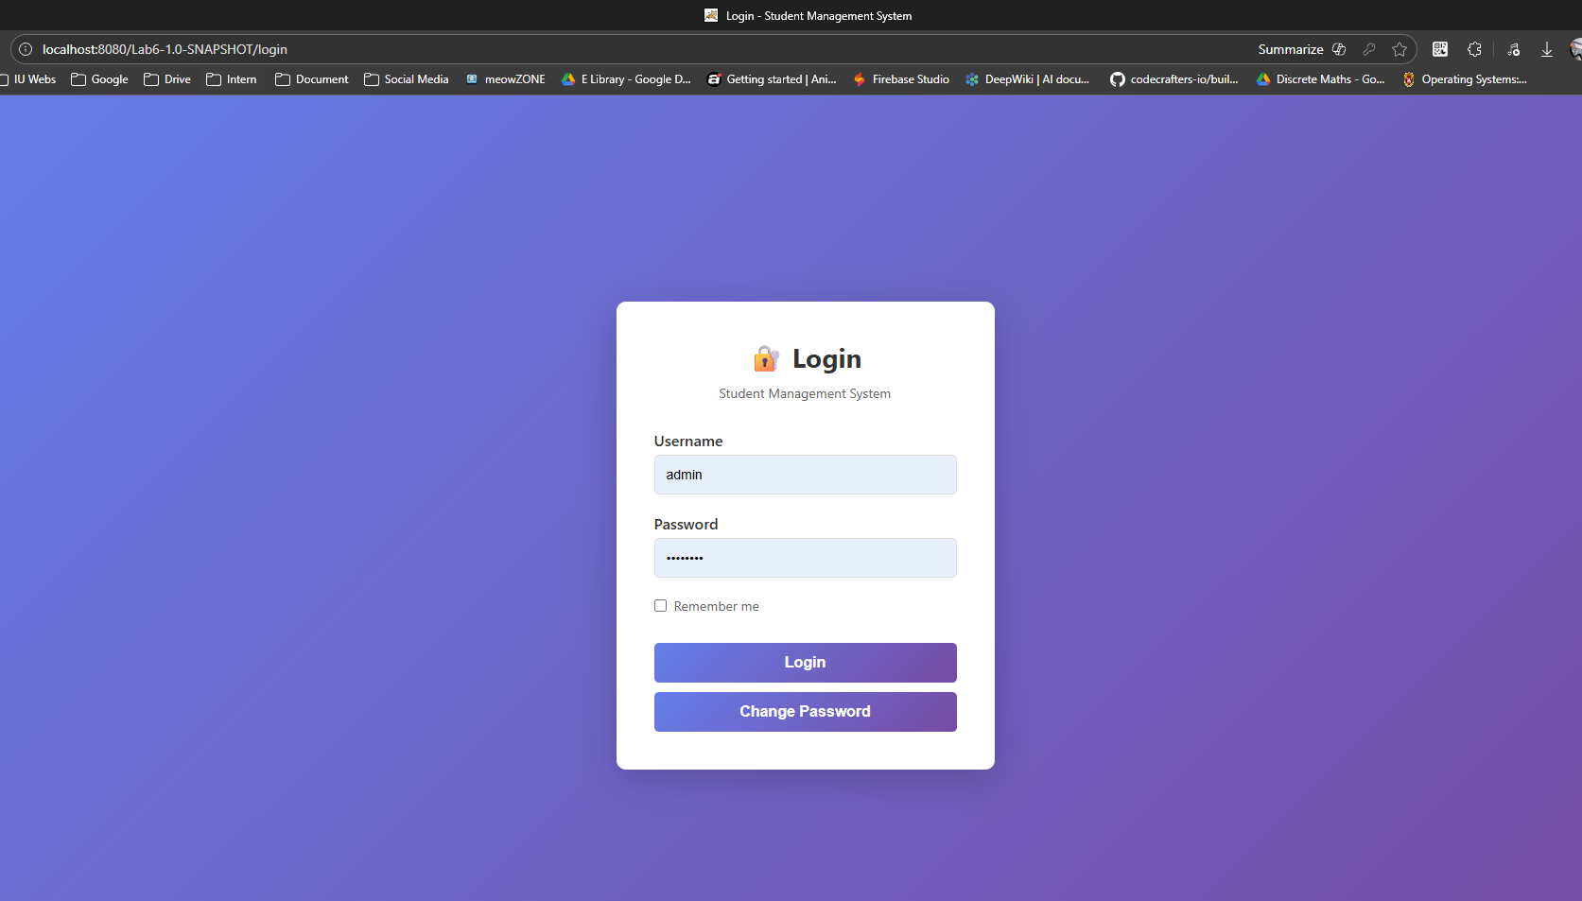

Login with wrong credentials (error message)
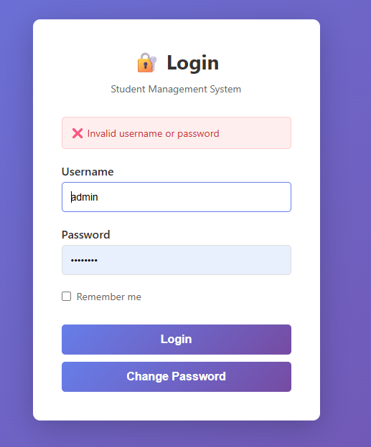

Dashboard after login
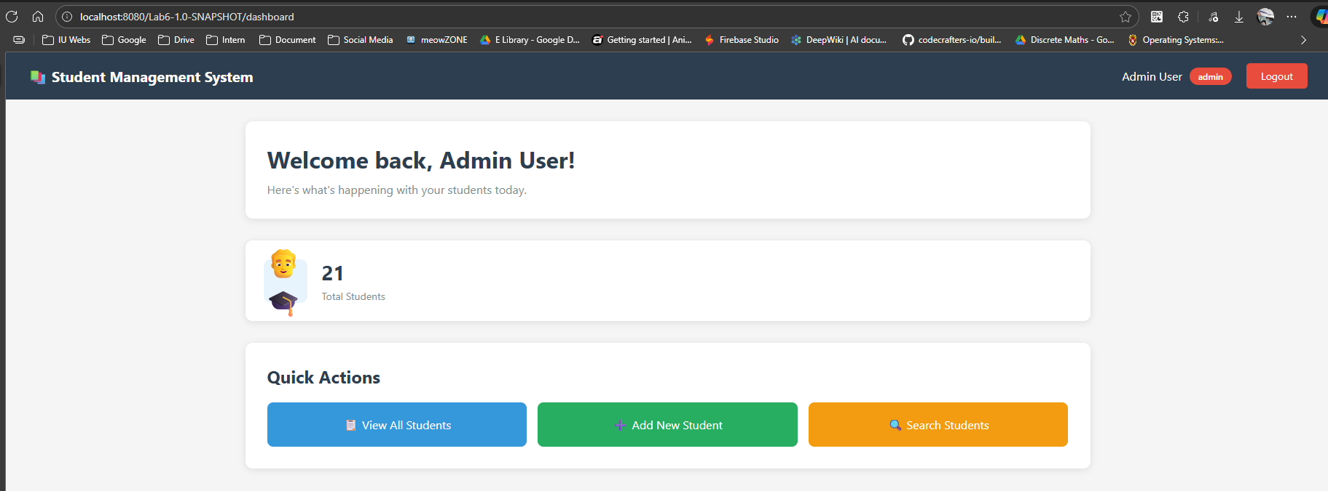
Student list as admin (with Edit/Delete buttons)
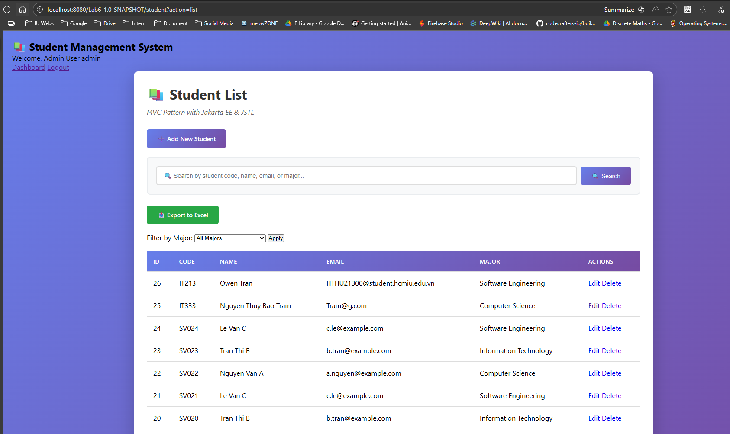

Student list as regular user (without Edit/Delete)
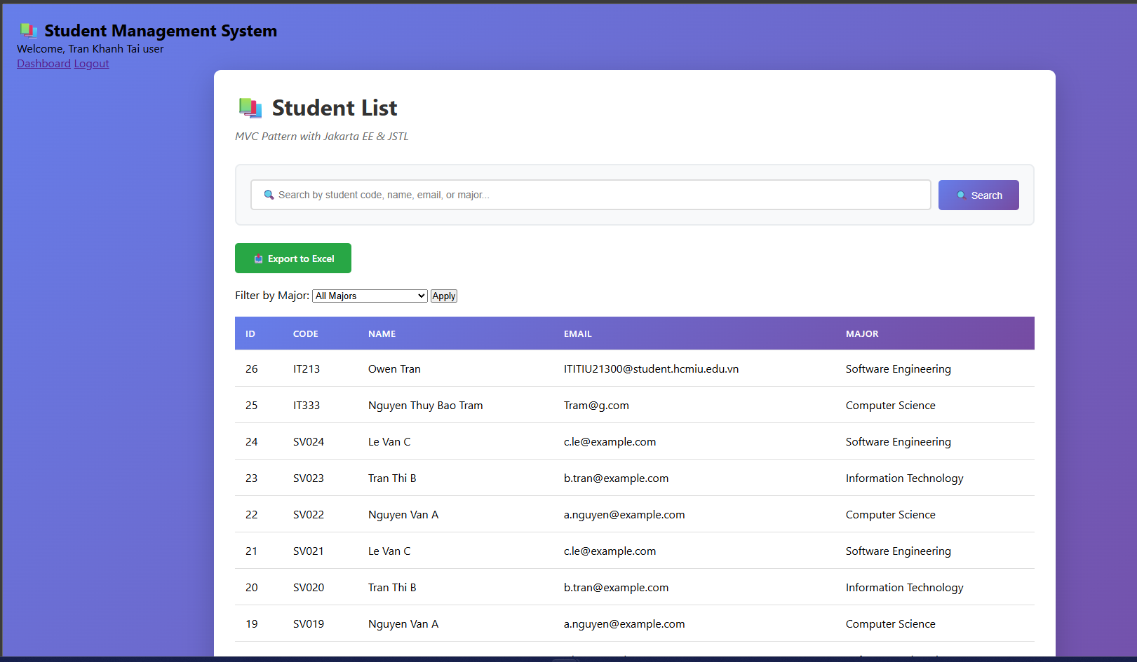
Accessing protected page without login (redirect)
Try to access : http://localhost:8080/Lab6-1.0-SNAPSHOT/student?action=new
It will check if not loggin -> redirect to the login page.
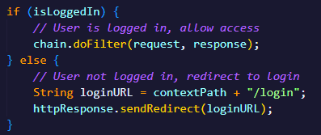
Non-admin trying admin action (blocked)
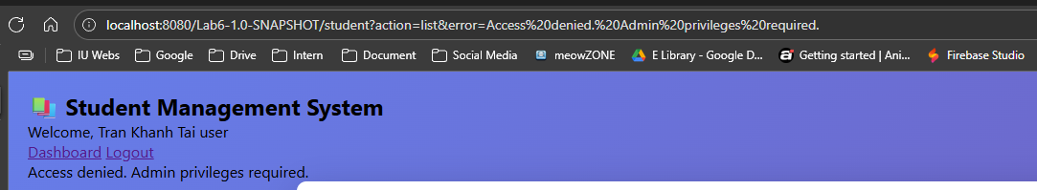

Logout success message
